Customer Shopping Behavior Analysis

This project analyzes customer shopping behavior across different age groups, genders, subscription levels, and product categories. The goal is to clean the data, run advanced analysis, and build a Power BI dashboard so that business managers can understand who buys what, how much revenue is generated, and how discounts and subscriptions affect sales. [web:1][web:20]

After this paragraph, paste:
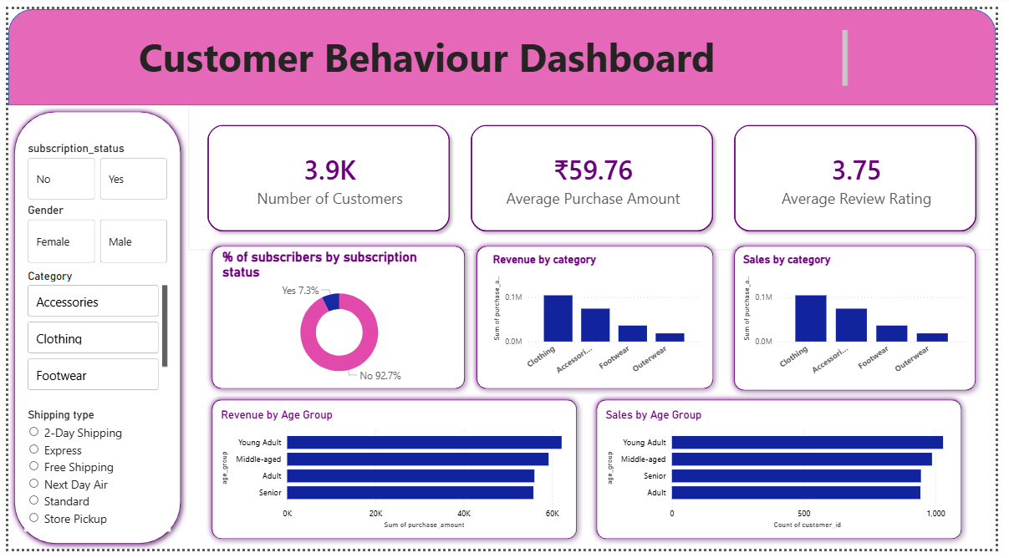 Figure 1: Power BI dashboard – Customer Shopping Behavior Analysis

2. Business Problem Statement
An online retail company wants to understand:
- Which age group and gender generate the most revenue.
- How product categories and discounts influence total sales.
- Whether subscription‑based customers spend more and buy more often.
The project aims to:
- Clean and prepare the raw data using Python (pandas).
- Perform detailed business analysis using SQL.
- Visualize insights in Power BI.
- Create this project report and upload everything to GitHub.

3. Dataset Description
Dataset type: Customer shopping / sales dataset (CSV format)
Approximate size: Around 3,900 rows and 18 columns (similar to practice datasets for this project). [web:23]

Key columns:
- CustomerID – Unique ID of each customer
- Age – Age group or numeric age
- Gender – Male / Female
- Subscription – Yes / No for subscription or membership
- Category / Item Purchased – Product or product category
- Purchase Amount / Revenue – Sales value per order
- Discount Applied / Discount – Whether a discount was given and its amount
- OrderDate – Date of purchase

This dataset simulates real‑world transaction data that a retail company might use for analytics.

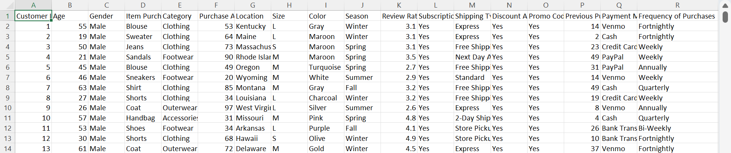 Caption: Figure 3: Sample dataset (CSV view)
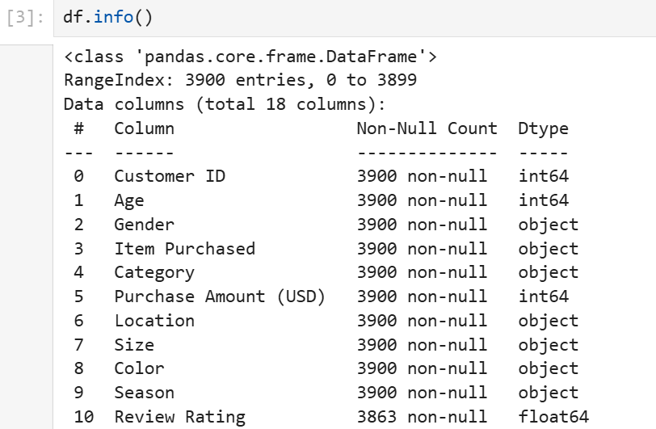

4. Tools & Technology Stack
- Python (pandas, NumPy) – For loading the CSV, handling missing values, removing duplicates, and creating new columns (e.g., NetRevenue = Revenue – Discount). [web:1][web:19]
- SQL – For queries on:
- Revenue by gender
- Revenue by age group
- Product‑wise sales and discount impact
- Subscription vs non‑subscription customer behavior [web:1][web:10]
- Power BI – For creating interactive visuals such as:
- Bar charts (revenue by gender, by age group, by product category)
- Line charts (revenue trends over time)
- Tables (top‑selling products, discount‑heavy items) [web:1][web:9]
- GitHub – For version control and sharing the project (Python scripts, SQL files, Power BI file, README, and project report). [web:1][web:15]

5. Step‑by‑Step Workflow
5.1 Data Cleaning in Python
In Python, the data was loaded using pd.read_csv() and then:
- Missing values and duplicates were checked and cleaned.
- Data types were corrected (Age, Revenue, Discount).
- New columns like NetRevenue were created.
- The cleaned data was saved as a new CSV file for SQL and Power BI.

After this paragraph, paste:
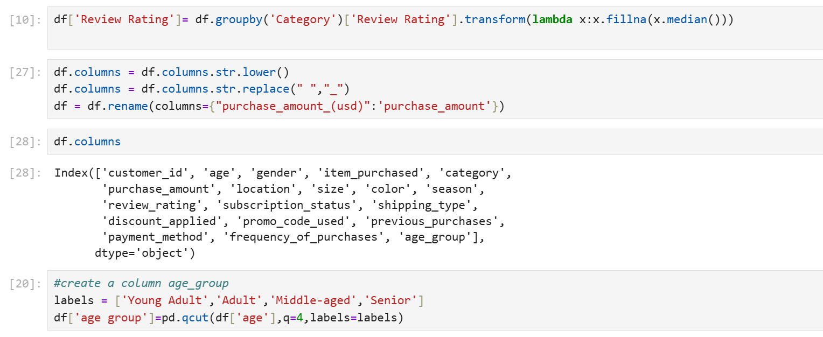
Figure 5: Data loading and cleaning in Python

5.2 Analysis using SQL
SQL queries were written to answer:
- Which gender has higher total revenue?
- Which age group generates the most revenue?
- Which products have the highest revenue and discount impact?
- Do subscription customers buy more and spend more?

After this paragraph, paste:
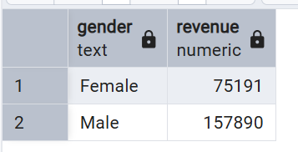
Figure 6: SQL query – Revenue by gender
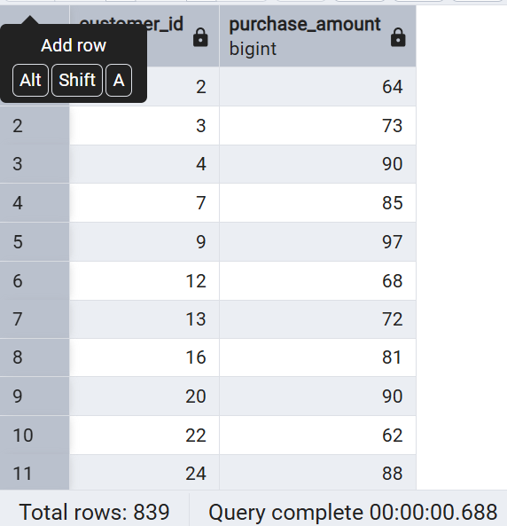
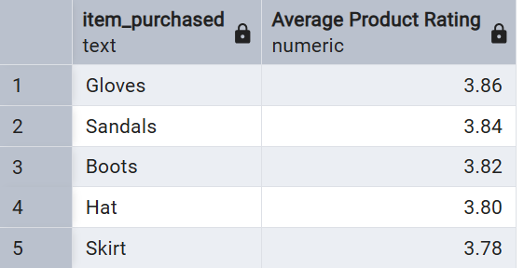
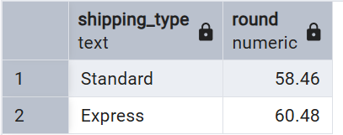
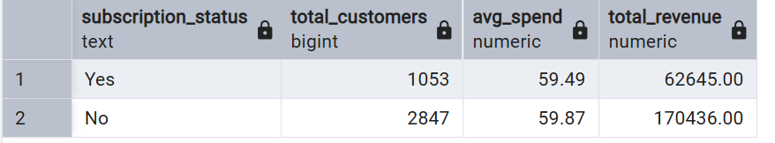
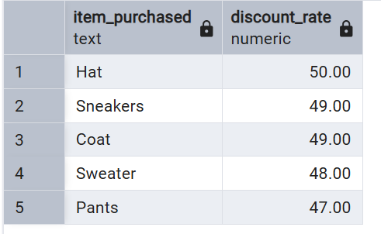
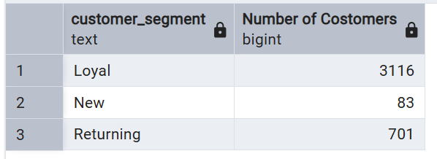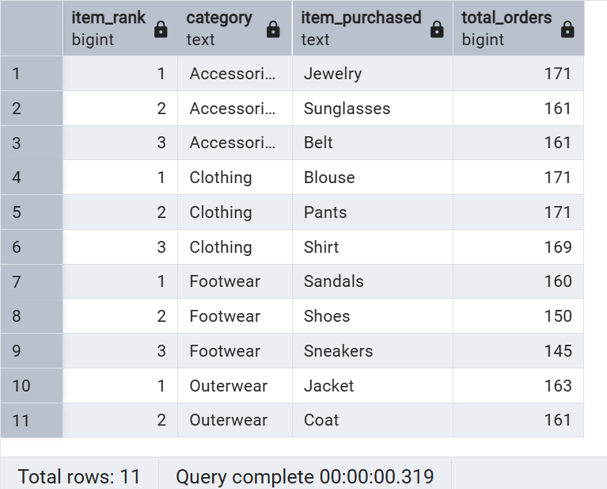
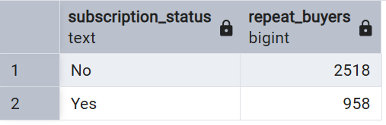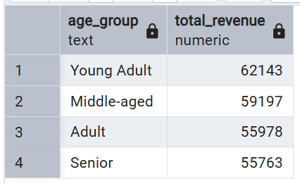

5.3 Power BI Dashboard
In Power BI:
- Connected to the cleaned CSV (or SQL database).
- Created:
- Bar charts (revenue by gender, by age group, by product).
- Line chart (revenue trend over time).
- Tables (top‑selling products, discount‑heavy products).
- Slicers (for filtering by age, gender, subscription status).

Figure 9: Overall Power BI dashboard
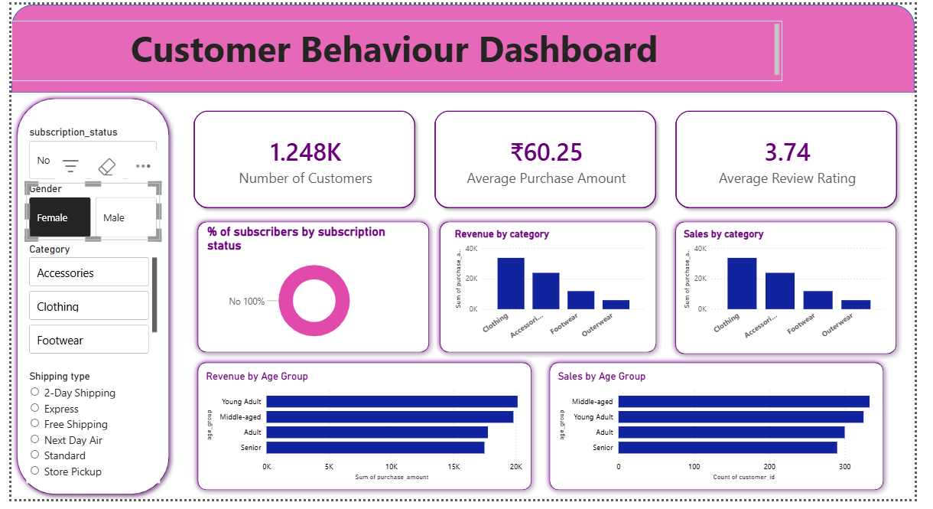
6. Key Insights
- Gender‑wise revenue:
- Female customers generally contribute higher total revenue compared to male customers. [web:23]
- Age‑group revenue:
- The 25–35 age group shows the highest revenue contribution, making it the most valuable segment.
- Younger customers (18–24) are more sensitive to discounts, buying more when offers are applied. [web:20][web:23]

- Discount impact:
- Products with high discounts see more sales volume, but sometimes lower profit if the discount is too deep.
- A few products are discount‑heavy but low‑value, suggesting the need for price optimization. [web:20][web:23]

- Subscription behavior:
- Customers with an active subscription have higher average spending per order and more frequent purchases.
- Subscription programs help with customer retention and loyalty. [web:20][web:23]

7. Recommendations
1. Focus marketing on high‑value segments:
- Target females and the 25–35 age group more strongly through ads, emails, and offers. [web:20]

2. Optimize discount strategy:
- Apply heavy discounts to high‑margin products, not to low‑margin items.
- Avoid turning profitable products into loss‑makers through excessive discounts.

3. Improve subscription programs:
- Offer exclusive benefits (early access, special offers, loyalty points) to push more customers to subscribe.

4. Rebalance product mix:
- Promote high‑revenue, high‑margin products more and reconsider or bundle low‑margin, discount‑dependent items.

5. Use the Power BI dashboard daily / weekly:
- Track key metrics such as revenue by age, gender, product, and subscription status to detect trends and adjust quickly. [web:1][web:9]

8. Conclusion

This project demonstrates a full end‑to‑end data analytics workflow: from data cleaning in Python, analysis in SQL, visualization in Power BI, and documentation in this report. It can be used as a portfolio project for college, interviews, or online profiles to show real‑world‑style analytics skills. [web:1][web:11]

